What is the Metaverse?  The Metaverse is an extension of our three-dimensional physical world into the 4th dimension of thought – what your senses ‘see’ your mind believes We call it XR or ‘extended reality’  It is created by code on a computer, just like a website but displayed in a different way. Space in the metaverse depends on the space available on the computer to hold and operate the code so the ‘size’ of the metaverse is limited  Instead of a 2 dimensional ‘flat’ webpage it appears as a 3-dimensional space. We call those spaces ‘land’ or correctly ‘virtual land’  Up until now most metaverses have been for games or fantasy environments but now we are moving into retail stores, arts and entertainment platforms and business and educational environments much more like the ‘real’ world. | Timescales - Graph on this page  The internet was born in 1969 but took 27 years to reach 1% of the global population. The metaverse started in 1994 but now n 2022 has still not quite reached that level.  The internet went on to grow to reach 68% of the global population in 2022. Where is the metaverse going and how long will it take to reach that level? The only way is up, and it will take a lot less time  Back in the 1980s the ‘mobile phone’ was launched, it looked like a hand held radio, the size of a brick, an aerial you had to pull up and a heavy briefcase to hold the battery – you could only talk with a button saying ‘talk – ‘listen’, there was no text.  20 years later we had smartphones with more processing power and functions than a mainframe computer of the ‘80s. Progress is getting quicker, just imagine where we could be in the metaverse in ten years. Any ideas?
It's time to switch from your webspace to the metaspace and the easiest way is with Megaverus  What is Megaverus?  Megaverus means the ‘great positive’. It’s a family friendly metaverse concentrating on education business and entertainment. It isn’t a ‘game’.  It’s ‘extranational’ it doesn’t belong to any nation, it’s also ‘culture neutral’. Anyone who has a positive mindset is welcome regardless of their origin or background  It’s planet friendly, consuming less power to run than one average city block in the ‘real’ world. There’s no need for transport or utilities infrastructure so no space is wasted. To get from place to place we simply ‘teleport’.  Megaverus is a community. The inhabitants (those who own the land) will elect a ‘council’ to make decisions about what goes on and what doesn’t | What’s in it for you?  There are three ways you can participate in Megaverus:  Own Land – which you can build on and use, sell, or rent out. In a way it’s the 3D equivalent of your web page. What would you do with it?  Show video clips here (when available)  Be an Ambassador and introduce people to Megaverus to earn a commission according to how they engage. Could you do what I’m dong now?  Become a Member when you can participate in other ways such as speaking, entertaining, holding events and so on. What would interest you?  You can of course do all three. Which one would you like to hear more about first?  Go to the specific script for their first choice, or if it’s all three start with land  Talking about being a Member leads on to Land  Talking about being an Ambassador leads on to Land  Talking about Land leads on to being an Ambassador

What is the Metaverse?  XR : 3rd dimension (physical) -> 4th dimension (mind)  Code on computer  Volume of metaverse = size of server. Size limited  2 dimensional webpage -> 3 dimensional ‘land’  Games + Fantasy -> Education + Business + Entertainment | What happened?  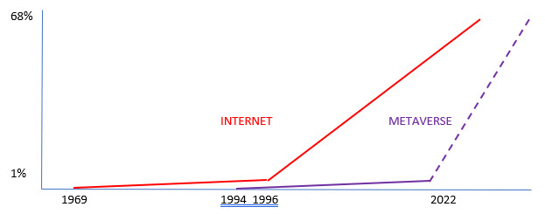  Time to upgrade!
Webspace -> ‘Metaspace’ = Megaverus  What is Megaverus - It’s not a game!  The Great Positive  Family friendly for Education, Business, Entertainment  Extranational, culture neutral - the place for positive people  Planet Friendly  Community based | What’s in it for you?  LAND  Land for shops, offices, entertainment, education. Use, sell or rent. Your ‘web page in the metaverse’  AMBASSADOR  Introduce people – get paid commission  MEMBER  Participate as a speaker, entertainer, promoter etc.

What is the Metaverse? | What happened?
Megaverus | What’s in it for you?

